

**“EASCO” Flush Bottom Ball Valve** (Single Pc. Design Flanged End)

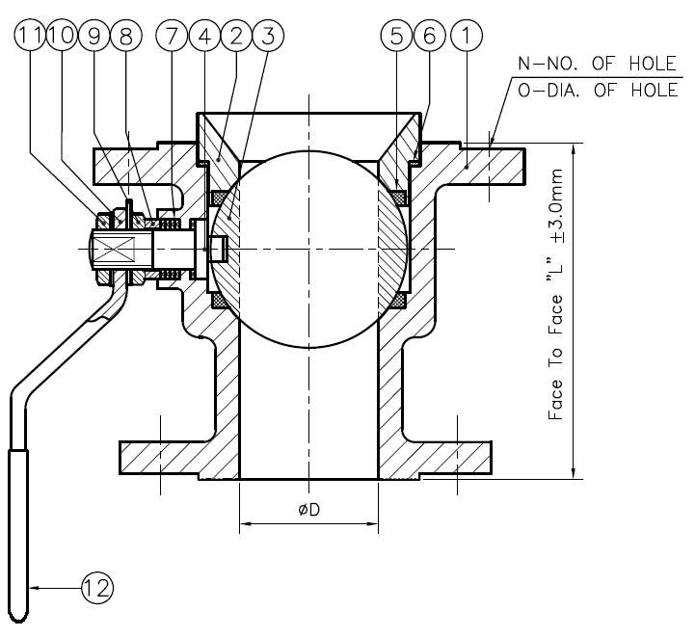

**Features: -**

* Low Operating Torque
* Leak Tight Stem Sealing
* Pressure Rating – 150#
* End Connection – Flanged End, RF
* Flange Drilling – As per ANSI B16.5, 150#
* Face to Face – Manufacturing Std.
* **Operation – Manual Hand Lever Operated**

**45 Degree**

**Testing Standard: - BS 6755**

|  |  |  |
| --- | --- | --- |
| Test Pressure in PSIG | | |
| Test | Hydrostatic | Air |
| Pr. Rating | 150# |
| Body | 450 |  |
| Seat | 325 | 80 |

**Part List: - Standard Dimension (150#): -**

|  |  |  |
| --- | --- | --- |
| **No.** | **Part Name** | **Materials** |
| 01 | Body | ASTM A351 Gr. CF8 / CF8M |
| 02 | Ball | AISI 304 / 316 |
| 03 | Stem | AISI 304 / 316 |
| 04 | Ball Seat | PTFE / GFT / CFT |
| 05 | Body Seal | PTFE / GFT / CFT |
| 06 | Gland Seal | PTFE / GFT / CFT |
| 07 | Gland Bush | SS |
| 08 | Gland Nut | SS |
| 09 | Hand Lever | SS |
| 10 | Hand Lever Nut | SS |
| 11 | Lever Sleeve | PVC |

|  |  |  |  |  |
| --- | --- | --- | --- | --- |
| **SIZE**  **(MM)** | **Bore**  **(MM)** | **F to F**  **(MM)** | **Vessel Side Flange Size** | **Outlet Side Flange Size** |
| **25x40** | 25 | 82 | 40 | 25 |
| **40x40** | 40 | 105 | 40 | 40 |
| **40x50** | 40 | 105 | 50 | 40 |
| **50x50** | 40 | 105 | 50 | 50 |
| **50x65** | 50 | 120 | 65 | 50 |
| **50x80** | 50 | 120 | 80 | 50 |
| **65x65** | 65 | 122 | 65 | 65 |
| **65x80** | 65 | 122 | 80 | 65 |
| **80x80** | 65 | 122 | 80 | 80 |
| **80x100** | 80 | 140 | 100 | 80 |
| **100x100** | 80 | 140 | 100 | 100 |
| **100x150** | 100 | 180 | 150 | 100 |
| **150x150** | 100 | 180 | 150 | 150 |

**Due to continuous development Program, the design & data given in this leaflet are subject to change without prior notice.**

**ANITA ENGINEERING WORKS**



58-59, Narayan Estate, Opp. Shree Ram Estate, Nr. CMC Ltd. Odhav, Ahmedabad-382415, Gujarat, India

Phone: +91 79 22974101, Fax: +91 79 22875014

Email: eascovalves@yahoo.com, eascovalves@gmail.com, Web: [www.eascovalve.com](http://www.eascovalve.com)

